Vukice Mitrovic 62, 11000 Beograd, Serbia
tel/fax: + 381 11 2449 275
info@balkanexpert.rs
license OTP 54/2013

Day 1: Belgrade - Visegrad (Bosnia & Herzegovina) - Šargan Eight Train Drvengrad/Mecavnik

This morning we will take road to south – west Serbia. We will follow the banks of river Drina which forms the border between Serbia and Bosnia & Herzegovina. We will have lunch at the beautiffull settings on the river Drina near the Lake Perucac.
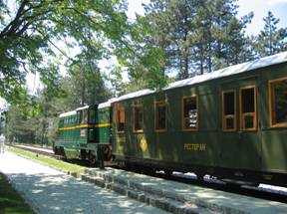
Latter we cross River Drina and the border of Serbia into Bosnia & Herzegovina. We will visit town of Visegrad, nestled here in the valley at a particularly beautiful point. Just like the well-known city of Mostar, Višegrad also has a famous stone bridge that hails from the Ottoman era. The bridge in Višegrad was designed by the famous Ottoman architect Sinan and completed in 1571. It is an Ottoman structure of pumice stone, and was the inspiration for a novel by Ivo Andric, “The Bridge On The River Drina” which got him the 1961 Nobel Prize for Literature. We will also visit “Andric Grad “
We will cross the border back to Serbia to continue our journey by a nostalgic journey by the old steam engine “Šarganska Osmica” for 15km, crossing breathtaking scenery through 20 tunnels, 10 bridges and across many viaducts. Once, this narrow gauge train, affectionately known as the Ćira (Chira), used to be the only traveling solution for the people of the area. The train cut its path through the astonishing landscapes of Serbia and Bosnia, on its way from Belgrade to Sarajevo, and further on to Dubrovnik. Now it is possible to ride a 15km part of it, famous for its curves in the shape of the number 8 that made it possible to climb the steep slopes of the mountains Šargan and Mokra Gora. The track was reconstructed in 1999.During the ride, the train makes a few stops, one of which lasts 20 minutes to let you take some fabulous photographs, enjoy the views, or have a refreshment in the cafe of a tiny and charming 'railway station'.
Our final destination of the day will be ethno village of Drvengrad/ Mecavnik – idea of famous film director Emir Kustudica where we will have dinner and overnight.
Overnight at Mokra Gora: Ethno village – Mecavnik 4* (L, D)

Day 2: Mecavnik - Sirogojno Ethno Village – Belgrade
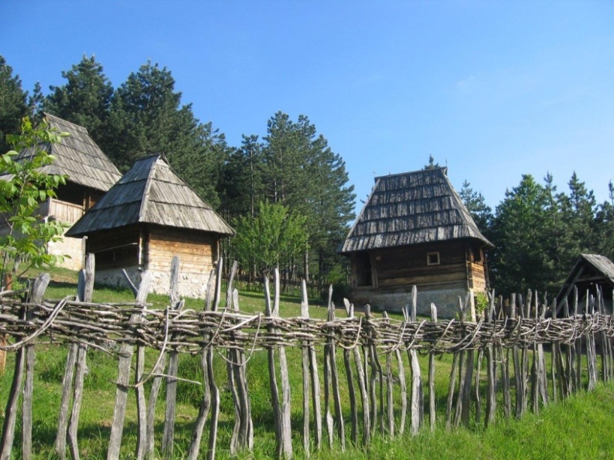
After breakfast we will continuing our journey we will ascend to Mount Zlatibor, one of the most popular mountain resorts in Serbia, both in summer as well as winter. Zlatibor is a National Park famous for its beauty and intact nature. It is a mountain of golden pines, after which it got its name (Zlatan - golden, Bor – pine tree). A short drive through the beautiful countryside will take us into an area where the vegetation will change its look, giving you the impression that you are in a jungle. Here you can find unique flora and fauna, such as the Omorica, the rarest of the pine trees endemic to this area. We will pay a visit to the unique and very charming ethno village of Sirogojno. It is an open-air museum of traditional architecture, as well as an exhibition of handicrafts and world famous hand-knitted clothes. We will a unique traditional lunch there.
Latter in the afternoon we will return to Belgrade.
(B, L)

B- Breakfast L – Lunch D – Dinner

Including private transportation by bus, English speaking guide, all entrances, 01 night accommodation in Mecavnik, 01 dinner in Mecavnik, 01 lunch on the river Drina - Perucac, 01 lunch in ethno village Sirogojno, ticket for Sargan Eight train

MINIMUM 10 passengers

Price: 210.00 EUR per person in twin room
Single Supplement: 25.00 EUR

ATTENTION: PASSENGERS HAVE TO MAKE SURE IF THEY NEED VISA FOR BOSNIA & HERZEGOVINA

All hotels are carefully chosen for their character or best central location or they are simply the only option at certain destinations. All of them can be changed on a request. The categories mentioned by the hotel names are according to the local standards and sometimes do not reflect to Western standards

Trip organized by: “BALKAN EXPERT” d.o.o. license no. OTP 54/2013
Tour available with general condition of travel of “BALKAN EXPERT”

