Vukice Mitrovic 62, 11000 Beograd, Serbia
tel/fax: + 381 11 2449 275
info@balkanexpert.rs
license OTP 54/2013

Fruška Gora - Sremski Karlovci – Petrovaradin - Novi Sad
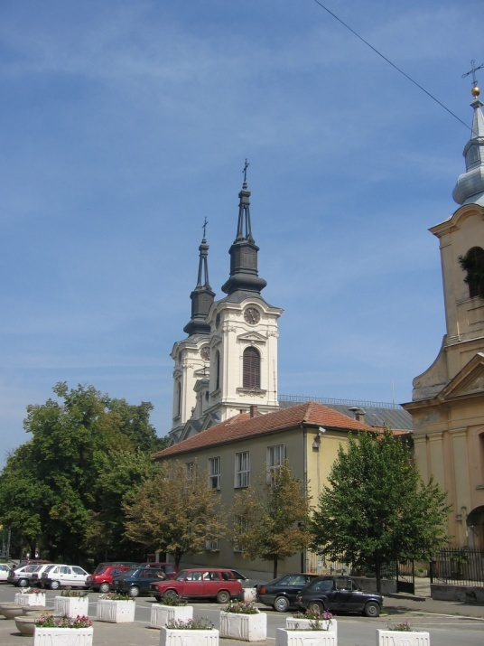
We will take a drive on the old road north, crossing small villages of the province of Vojvodina and the region of Fruška Gora - the only hill in the entire Panonian Valley. Located on the slopes of this hill are 17 medieval monasteries, which for several centuries represented the spiritual centre of the region, often labelled as the Serbian Mt. Athos. We will visit Monastery Krušedol, founded in the 16th century and known for its attractive location, historical importance, and a variety of decorative frescos in its church.
Our next stop will be Sremski Karlovci, a picturesque baroque town which was a Serbian religious and educational centre in the 18th and 19th centuries. There, we will enjoy the Baroque-style fountain from 1790 and the Karlovci High School. This site dates from the end of the 19th century and contains decorative elements reminiscent of mediaeval Serbian buildings. We will also visit the Patriarch's Palace, once the most imposing building in the whole region, as well as the Cathedral from the mid-18th century.
We will make a stop to treat ourselves today with lunch in a typical “charda”, a small restaurant usually built to float on the river. These are known for serving great freshwater fish specialties.
En route to Novi Sad we visit the fortress of Petrovaradin, built in the 17 and 18th centuries, and once called "Gibraltar on the Danube". This Austrian artillery fortification is situated above the river and represents the second largest structure of its kind preserved in Europe. Built by Austrians at the spot of former Roman, Byzantine and Hungarian settlements, the fortress plays a very important role in the life of the town even today, as many cultural events are organized there.
Novi Sad is one of the biggest cities of Serbia and is the capital of the region of Vojvodina. It is a modern, lively city with many growing businesses, but, at the same time, it maintains a beautiful taste of the past. We will have a walking tour of the centre of Novi Sad to visit the main Orthodox Cathedral, the main Catholic Cathedral, and then continue to have a walk on the famous Dunavska street.
In late afternoon we will return to Belgrade.

Including private transportation by bus, English speaking guide, all entrances, lunch - tour lasts 7 hours

MINIMUM 10 passengers – 70.00 EUR per person

Trip organized by: “BALKAN EXPERT” d.o.o. license no. OTP 54/2013
Tour available with general condition of travel of “BALKAN EXPERT”

