Vukice Mitrovic 62, 11000 Beograd, Serbia
tel/fax: + 381 11 2449 275
info@balkanexpert.rs
license OTP 54/2013

Manasija – Ravanica - Lazarica - Ljubostinja
We will leave Belgrade in the morning by driving south into the area of central Serbia. Our first visit will be Monastery Manasija, founded by Despot Stefan Lazarević in the first half of the 15th century. This monastery has the best preserved medieval fortification in the country. Its high defensive walls were once additionally protected by 12 towers and a series of hanging machicolations. This fortified area still contains the ruins of the old Refectory, the reconstructed monastic residence with a valuable private library, and the Church of the Holy Trinity with its exceptionally fine fresco paintings.
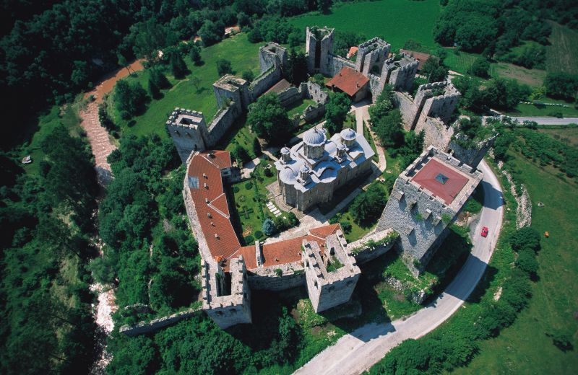
A short scenic drive away is Monastery Ravanica monastery, founded by the Serbian Prince Lazar in the second half of the 14th century. This is the most typical example of what is called the Morava School of Serbian medieval architecture. The monastery's five-domed Church of the Ascension displays rather badly damaged but very fine frescoes. A transparent coffin in the church contains relics of the great and highly devoted Prince Lazar, killed in the battle of Kosovo in 1389 and soon afterwards declared a saint.
We will continue our drive south to the town of Kruševac, the medieval capital of Serbia during the time of Prince Lazar in the second half of the 14th century. We will see the Lazarica Court Church, founded by the Serbian Prince Lazar in 1380. This church represents a fine architectural achievement, adorned with rich carved stone decoration on the arches, rosettes, windows and portals. As one of the earliest monuments of the Morava school, it long served as a model for Serbian builders.
Our next visit will be Monastery Ljubostinja founded by Prince Lazar's wife, Princess Milica in 1388. Its Church of Virgin Mary is considered to be one of the most elegant architectonic monuments of mediaeval Serbia: the domed building, situated in a very pleasant environment, displays the form of an inscribed cross combined with a trefoil. This is maybe the only Serbian monastery where the names of both the chief builder and painter have been preserved.
In the evening we will return to Belgrade.

Including private transportation by bus, English speaking guide, all entrances, lunch - tour lasts 9 hours

MINIMUM 10 passengers – 80.00 EUR per person

Trip organized by: “BALKAN EXPERT” d.o.o. license no. OTP 54/2013
Tour available with general condition of travel of “BALKAN EXPERT”

