Vukice Mitrovic 62, 11000 Beograd, Serbia
tel/fax: + 381 11 2449 275
info@balkanexpert.rs
license OTP 54/2013

Golubac – Lepenski Vir - Donji Milanovac
Early in the morning we will begin our day today by a voyage to the distant past.
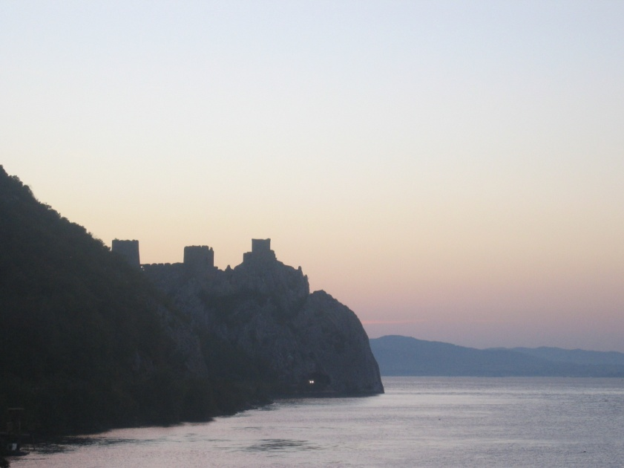
We will drive to the east, first trought the country side and then we will continue to follow the banks of the Danube. We will soon arrive to the fortified town - Golubac, one of the best preserved medieval towns in Serbia. It is located at the entry of Iron Gate Gorge on the Danube (the biggest gorge in Europe) and it is dated to 14th century.
A beautiful drive down the Danube, trough iron Gate Gorge, will take us to Lepenski Vir. Dated to 6000 years BC, it is the settlement of one of the oldest Neolithic civilization in Europe, and a whole era was named after this site. As the myth says, it was founded by one of Noah’s sons after the deluge. We will visit the site where many houses of the village from that era can be seen together with famous and very unique sculptures in the shape of human heads.The first excavations were made on the site in 1965. In 1966 it was listed as a cultural monument of Yugoslavia. It was only in 1967 that its importance was fully understood after the discovery of the first Mesolithic sculptures. The excavations ended in 1971 when the whole site was relocated 29.7m higher to avoid flooding from a new artificial lake created in the Iron Gates gorge. The main contribution to exploration of this site was through the work of professor Dragoslav Srejović of the University of Belgrade. 136 buildings, settlements and altars were found in the initial excavations in 1965-1970. Lepenski Vir was declared a Monument of Culture of Exceptional Importance in 1979, and it is protected by the Republic of Serbia.
Lunch will be organized in the restaurant close to the river Danube and Lepenski Vir.
We will also visit nearby small town of Donji Milanovac.
In the evening we will return to Belgrade.

Including private transportation by bus, English speaking guide, all entrances, lunch - tour lasts 9 hours

MINIMUM 10 passengers – 80.00 EUR per person

Trip organized by: “BALKAN EXPERT” d.o.o. license no. OTP 54/2013
Tour available with general condition of travel of “BALKAN EXPERT”

