# Vukice Mitrovic 62, 11000 Beograd, Serbia



**tel/fax: + 381 11 2449 275**

info@balkanexpert.rs

**license OTP 54/2013**

**Avala - Topola/Oplenac – Bukovicka Banja /Arandjelovac**

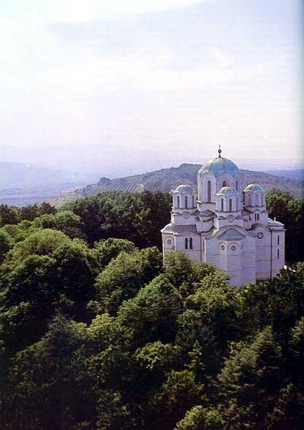In the morning we will have a short drive to neighboring Mount Avala for a visit to the Mausoleum of the Unknown Hero, made by the famous sculptor Ivan Meštrović. This is situated on the mountain top (511 m), and offers a spectacular view of the landscape around the capital.

Then we will continue to the central part of the hilly Šumadija region, known as the cradle of Serbian uprisings against Ottoman rule in the 19th century. Upon arrival to Topola, we will visit the Residence of Karadjordje(now a museum dedicated to the leader of the First Serbian Uprising), the Church of Our Lady, built by Karadjordje (1811-1813), and two stone towers which are left from what was once a mighty fortification. Then, a short drive away is St. George Church, built after WWI by the King of Serbia, Petar I, on top of Oplenac. This church is unique among all the monuments in Serbia, with columns made of marble, an iconostasis of local marble, and mosaics covering almost 3,500 sq. meters, which include 725 scenes and 1,500 human figures.

Lunch will be organized in Topola.

In the afternoon we will visit Bukovička Banja and its attractive park ornamented with many white marble sculptures. On our way back to Belgrade we will make a brief stop at the village of Orašac, where the historic meeting of Serbian rebels took place in 1804.

**Including private transportation by bus, English speaking guide, all entrances, lunch - tour lasts 7 hours**

**MINIMUM 10 passengers – 70.00 EUR per person**

**Trip organized by: “BALKAN EXPERT” d.o.o. license no. OTP 54/2013**

**Tour available with general condition of travel of “BALKAN EXPERT”**