Vukice Mitrovic 62, 11000 Beograd, Serbia
tel/fax: + 381 11 2449 275
info@balkanexpert.rs
license OTP 54/2013

Day 1: Belgrade - Studenica (UNESCO) – Sopocani (UNESCO) – Novi Pazar
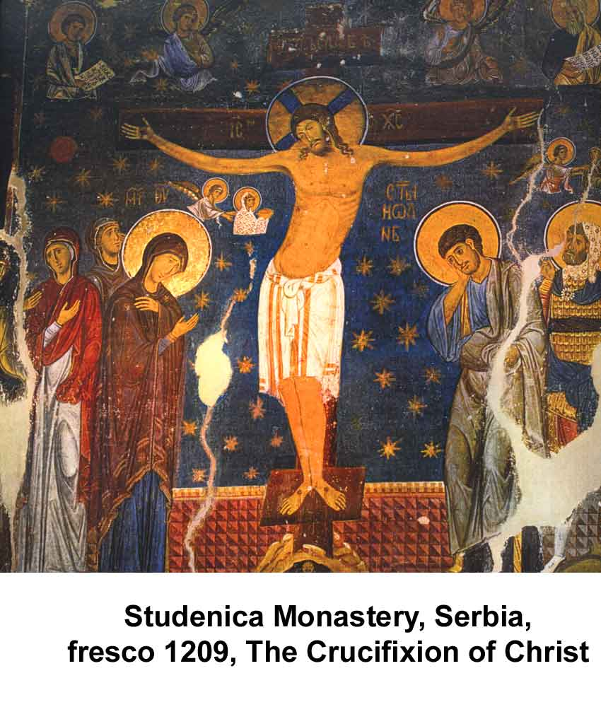
Early morning we will leave Belgrade and go south. We will drive along river Ibar, trough beautiful countryside to the Monastery Studenica (UNESCO site), founded by Stefan Nemanja. This is considered to be the crowning achievement of medieval culture and art in Serbia. The monastic complex consists of the fascinating Church of the Virgin (1183 - 1196), the Church of SS Joachim and Anne (also known as the King's Church) and the Church of St. Nicholas, a simple single-nave building. The monastery circle contains monuments raised over a period of 130 years, and several Serbian rulers had a hand in their construction. At the start of this period, the young Serbian feudal state under Stefan Nemanja was consolidating its independence, and by King Milutin's reign it had reached the height of its political, cultural and economic power. The strengthening of the medieval state and of its ruler's might is naturally reflected in these monuments.
We will have lunch in the Monastery
After short drive south we will visit one of the most treasured sacral buildings of the Nemanjić era, the Monastery Sopoćani. It is an endowment of King Uroš from the 13th century, and its mural painting ranks among the most magnificent and beautiful in European medieval art. The monumentality of Sopoćani frescos, the harmony of colors, and the refinement of expression were all responsible for being granted a place on UNESCO’s World Heritage list. Dinner will be in the hotel.
Overnight in Novi Pazar: Hotel Tadz 4* (L, D)

Day 2: Novi Pazar – (KOSOVO) Decani (UNECSO) – Pec (UNESCO) – Pristina - Gracanica (UNESCO) - Belgrade (SERBIA )
Leaving Novi Pazar in the morning we will drive south towards Kosovo. Crossing the border, we will drive through Kosovska Mitrovica and northern parts of the region mostly inhabited by Serbs.
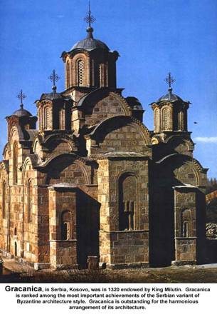
The Monasteries of the region of Kosovo and Metohija are of exceptional value. In the late middle Ages, this region was the center of the Serbian State and the Church. The most monumental building in medieval Serbia is the church devoted to Christ the Pantocrator at Dečani Monastery. King Stefan Dečanski initiated its building, while his son, the famous Emperor Stefan Dušan completed the work of his father in the 13th century. Dečani church boasts the richest and best preserved sculpture in the Romanesque-Gothic style, a lavish portal, and decorative windows. It bears witness to the regal origins of the Nemanjić’s and the rulers’ families of the founders. What makes this monastery exceptional is also its treasury, a safekeeping of precious old icons and other objects of superb value. The monastery is on the UNESCO World Heritage List. Next on our way will be the Patriarchate of Peć. The complex stands on its own in this area with its four churches. The oldest, dedicated to the Holy Apostles, was built in the mid 13th century, while the last one, devoted to St. Nicholas, dates back to the first half of the 14th century. The Patriarchate of Peć plays a major role in the Church and State history of Serbia.
We will stop for a lunch in the old town of Pec. We will continue our tour by driving to the capital of Kosovo – Pristina. We will have a panoramic tour of the town.
Our last visit today will be the Monastery Gračanica, with its monastery church devoted to Annunciation. The monastery was an endowment of King Milutin and was built in the early 14th century. Its architectural structure represents the apex of Serbian building that followed in the spirit of Byzantine tradition. This monastery stands apart as a work of harmonious proportions and extraordinary beauty and as such made its way to UNESCO list of World Heritage.
After visit we will cross the border back to Serbia and drive to Belgrade. We will arrive back to Belgrade late in the evening. (B, L)

B - Breakfast L – Lunch D – Dinner

Including private transportation by bus, 1 nights accommodation in Hotel Tadz in Novi Pazar, 1 breakfast , 1 dinner, 2 lunches, English speaking guide, all entrances

MINIMUM 10 passengers

Price: 295.00 EUR per person in twin room
Single Supplement: 15.00 EUR

All hotels are carefully chosen for their character or best central location or they are simply the only option at certain destinations. All of them can be changed on a request. The categories mentioned by the hotel names are according to the local standards and sometimes do not reflect to Western standards

Trip organized by: “BALKAN EXPERT” d.o.o. license no. OTP 54/2013
Tour available with general condition of travel of “BALKAN EXPERT”

